Printing Multi-Paged Documents

1. Open any Word document, click “File” from the menu bar, and select “Print.”

Picture of File menu bar in Microsoft Word with Print highlighted

2. Click on the “Properties” box.

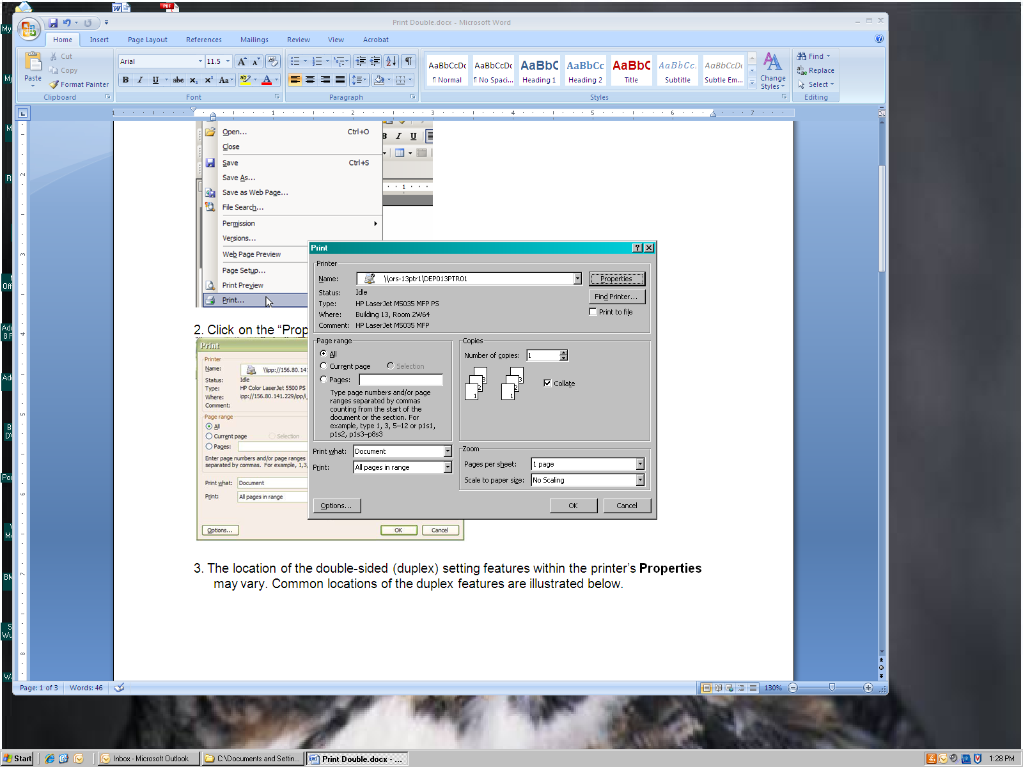

3. The location of the multi-page feature varies between printers. A few common examples are shown below.

