Print Documents in Draft/EconoMode Format

1. Open any Word document, click “File” from the menu bar, and select “Print”

Picture of File menu bar in Microsoft Word with Print highlighted

2. Click on the “Properties” box.

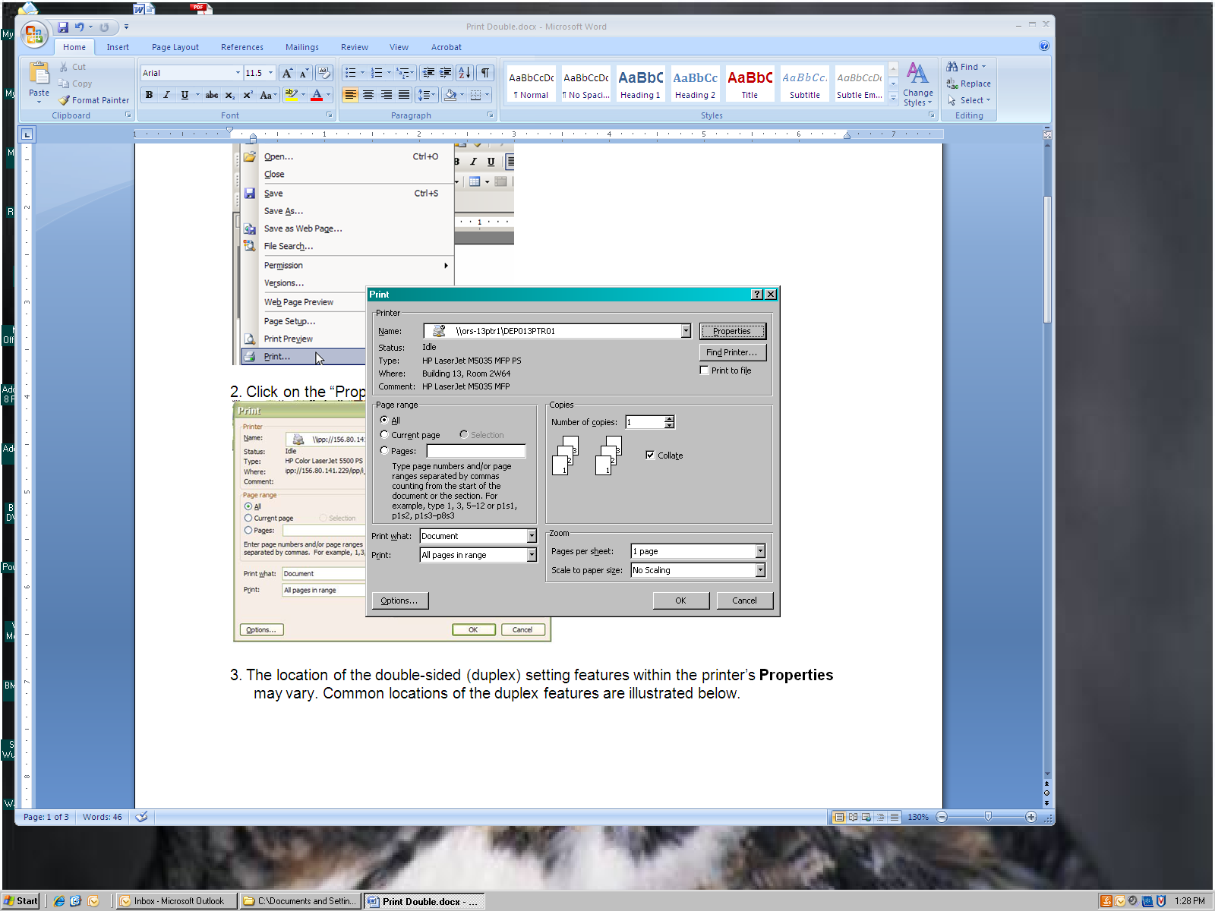

3. The location of the draft format varies by printer. A few examples are shown below.

