Print Double-Sided Documents

1. Open any document, click “File” from the menu bar, and select “Print”

Picture of File menu bar in Microsoft Word with Print highlighted

2. Click on the “Properties” box.

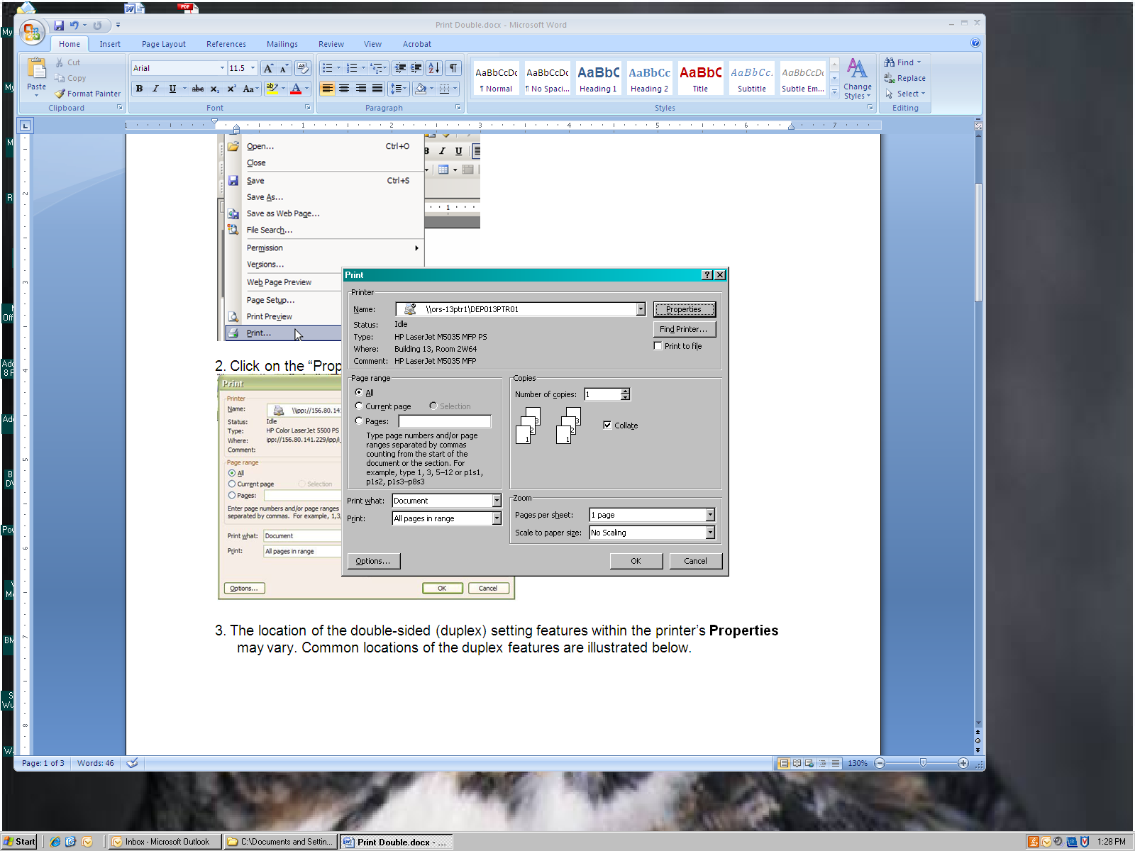

3. The location of the double-sided (duplex) setting features within the printer’s propertiesmay vary. Common locations of the duplex features are illustrated below.

Picture of Layout screen within "Properties". Under "Print on Both Sides" the "Flip on Long Edge" is selected.

