IC Guide to Design & Construction Workflow with Project Officer & IC POC Responsibilities

Step I. Submitting a Work Request / Project Planning

Submit a work request online at or (iwms.nih.gov). The deadlines to request construction projects for the year are listed at the top of the webpage. These dates change each fiscal year and vary based on the cost of the project. When filling out a work request, it is important to note that the IC Point of Contact (IC POC) will make decisions regarding project funding and the scope of work on behalf of the IC. After your request has been received, it will be assigned to a Project Officer (PO) who will contact the IC POC to arrange a kick-off meeting and gather information about the scope of work.

The PO and the IC POC will work together to develop a project plan which includes a Free Estimate (See Attachment 1), which includes rough estimates of the schedule, scope of work, and design and/or construction costs. The information in this estimate should not be considered final and is only meant to serve as a guide for project development. The time it takes to develop the project plan is based on the size, complexity and development of the scope provided by the user.

A Fee for Service (FFS) will be established with this plan and will be collected if the project continues. Your project plan will include a recommendation for contingency funds to cover any unforeseen conditions which may be encountered during the project. As we are not able to commit these funds, we are providing you this budget to set aside for use as issues arise. While the plan can be updated if necessary, the IC Fiscal Authority and the IC POC must sign off on the current project plan before the project can proceed and a detailed scope, Independent Government Estimate (IGE), and schedule can be developed. Once the final scope, IGE, and schedule are approved, the ORF Business Support Branch (BSB) will request a commitment.

For the duration of the project, the PO will submit weekly updates to the IC POC and other interested parties. The project status can also be obtained by accessing the work request link above and once there, clicking on the Search Requests button. Then either pull up the project by work request number if known, or search by POC, location and/or PO.

Step II. Design
The Office of Acquisitions (OA) will appoint a Contracting Officer (CO) to the project who will award a contract for the project design. The IC POC and the PO will meet with the project’s Architect/Engineer to discuss the program of requirements and to approve design drawings at each phase of development defined in the scope of work. Some projects may be good candidates for a design-build approach which means both the design and construction are under one contract. Other projects go through the Design – Bid - Build process depending on complexity and other factors. There are pros and cons to these approaches and your PO will recommend which path they believe is the best fit for your project.

IC Responsibility (See Attachment 2): The IC should contact CIT to designate a representative who will help you coordinate tech concerns throughout the design process. The CIT rep should be included in design coordination meetings and will be included in all design reviews. The drawings developed for construction will be used by CIT to contract a vendor to provide wiring and connectivity for your project.

Step III. Pre-Construction
After design completion, the PO will develop an acquisition package (scope, IGE and schedule) for construction funding commitment. Once approved by the IC, BSB will collect the funding commitment and the CO will award a contract for construction obligation.

The PO will arrange a pre-construction meeting to further clarify project expectations, timelines, responsibilities, and communications plans. The IC POC should attend this meeting. All parties should make sure that they are clear on the project scope, schedule, and budget before construction begins.

IC Responsibility: The IC is responsible for contacting DOHS to clear any labs before construction begins. If abatement is needed, ORF will coordinate the procedures, but the IC may be responsible for some of the associated costs (all currently covered by ORF). If the IC has any hazardous materials as part of their existing or future equipment for the space, please contact DOHS for their assistance in planning for the equipment removal/placement as applicable.

Step IV. Construction
The PO will hold biweekly (or other duration) progress meetings once construction begins. Any modifications to the project scope during construction must be processed through the PO and CO.

IC Responsibility: The IC POC must stay involved through progress meetings to know when additional orders will need to be submitted to NBS. See Attachment 2, Paragraph 6, for additional information.

Step V. Post-Construction
After construction, the IC POC and Project Officer will walk the site and create a punch list of any remaining construction issues to be done. Once the items on the punch list have been completed, then the IC POC will give a final sign off on the project. The PO will coordinate the final inspection with the Fire Marshal to obtain the Occupancy Permit.
The PO is responsible to initiate a housekeeping ticket after construction for service to resume to the space. Additionally, The PO will engage DEP to restart recycling services. Contact the DEP Solid Waste COR (currently Mansi Mehta) indicating the request and the location (building, wing, rooms, etc.) and copy the alternate COR (currently Joseph Stefan), and the recycling coordinator (currently Surakshya Pathak).

To further assist, the room should be updated in FIMS by that Team, as well to refer to for the impacted area in which collection containers are needed, this will help with our planning/placement along with site walkthroughs. The containers can be the blue bins for rooms, or large recycling containers for hallways.

IC Responsibility: The IC POC is responsible for contacting DOHS to arrange a walkthrough of lab spaces.

Step VI. Moves
IC Responsibility: The IC POC is responsible for coordinating the move process. This includes arranging furniture deliveries, moving services, CIT concerns, and other parts of the process during and after construction. Designate a move coordinator to work with the Fiscal Authority and decide the role of NIH movers as you plan ahead. It is recommended that you schedule a pre-move briefing with all relevant stakeholders and include a CIT representative in your meetings to address technical concerns.

Different steps of the moves process will need to be arranged at different times during and after construction. Some of the steps that you will need to take include the following:

- Enter an NIH help desk ticket one week prior to moving for the IC’s LAN support department to be able to set up computers on the day of the move. IT does not move computers.
- Notify NIH recycling services 2-4 weeks prior to move for recycling.
- Schedule trash collection services at the new location—a schedule may not be in your contract.
- Furniture—Order in advance to be prepared for delivery. Check market conditions for long lead time items.
- Surplus unneeded equipment 4-6 weeks before relocation if practical.
- Request new mailbox and mailstop codes

Step VII. Escalation
Consult your PO to address issues that arise during construction. If you are unable to resolve the issue, elevate to the appropriate Branch Chief within the Division of Design and Construction Management (DDCM).

If unsuccessful, elevate to DDCM Director Rick Robey rick.robey@nih.gov

If unsuccessful, elevate to ORF Director Dan Wheeland dan.wheeland@nilh.gov
or Lem Canady lemual.canady@nih.gov

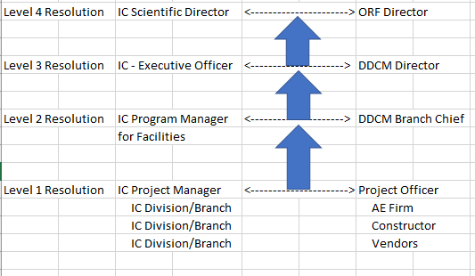

Issue Escalation Graph from Project Officer to ORF Director

Diagram of Project Management Issue Escalation process

Attachment 1 – Estimate Classification and Accuracy

Class 1-5 estimates are based on the percent of design completion and Range of estimated accuracy for each of these five classes (For Building and General Construction only)

Class 5: 0% to 2 % designed – little more than proposed building type, location, functional space building requirements (SF or m2), and number of stories are known at the time of estimate preparation.
Accuracy Low of -20% to -30%
Accuracy High of +30% to +50%

Class 4: 1% to 15% designed – preliminary room layouts, new proposed site plan, existing site plan, markups of existing drawings for demolition and utilities, design criteria report.
Accuracy Low of -10% to -20%
Accuracy High of +20% to +30%

Class 3: 10% to 40% designed – defined site civil information such as site plan, existing conditions, demolition drawings, utility plan, site electrical plans, room layouts, mechanical system layouts, plumbing layouts, and one-line electrical diagrams.
Accuracy Low of -5% to -15%
Accuracy High of +10% to +20%

Class 2: 30% to 70% designed – All drawings, plan views, elevation drawings and section drawings are complete; except detailed design schedules, architectural details and control diagrams, which may still be in draft form.
Accuracy Low of -5% to -10%
Accuracy High of +5% to +15%

Class 1: 65% to 100% designed – All drawings, plan views, elevation drawings and section drawings are complete; all detailed design schedules, architectural details, control diagrams, and specifications are complete.
Accuracy Low of -3% to -5%
Accuracy High of +3% to +10%

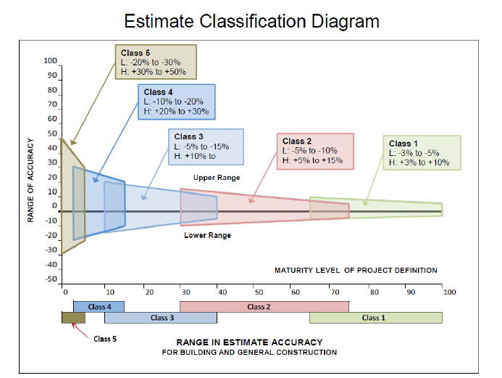

Image of Graph for Estimate Classification and Accuracy

Attachment 2 – IC Responsibility

- Submit a work request at (iwms.nih.gov). Also, see the “Search Requests” button for project status

- The IC Point of Contact (POC) helps draft a project plan with the assigned Project Officer (PO).

- The IC’s Fiscal Authority and IC POC review and sign off on the completed project plan. An example NHGRI checklist of key areas of interest can be found on ORF’s website at the following link. https://www.orf.od.nih.gov/ProjectResources/ProjectTools/Pages/checklistscientist.aspx

- The IC POC and PO meet with the project’s Architect/Engineer to discuss the program of requirements. The IC POC approves design drawings submitted at each submission phase as per the scope of work.

- The IC POC and Fiscal Authority attend a pre-construction meeting hosted by the PO to clarify the project’s scope, schedule, and budget before construction begins.
- The IC POC attends weekly construction progress meetings to keep updated on when additional orders must be submitted to NBS. Key submittal dates include the following;

•Phone (VOIP) and LAN orders
- Requests for Phone (VOIP), LAN and any other communications requirements should be made upon start of construction to determine equipment procurement and installation timeframes.
- Telecommunication system requirements need to be built into the design to support installation and activation of requirements.
- Contact the NIH Center for Information Technology (CIT) which provides the NIH community with a secure and reliable IT infrastructure and a variety of IT and scientific computing services that support its mission-critical research and administrative activities.

•Locksmithing
- Lock cylinder request if locks are being added/changed—60 days before completion
- Key lock requests—30 days before project completion,
- For orders of 20 or more keys, submit the order six weeks before completion.

•Signage - Request new signage 3 months prior to move in.
•Floor waxing orders - Submit once a room has been completed.
•Furniture- Order 6-8 weeks in advance.
•Enter an NIH help desk ticket one week prior to moving for the IC’s LAN support department to be able to set up computers on the day of the move. IT does not move computers.
•Notify NIH recycling services 2-4 weeks prior to move for recycling.

7. The AO coordinates the delivery, setup, and safety certification of laboratory equipment.

8.Pre-construction: The IC POC contacts DOHS to arrange a Lab Clearance walkthrough.

9. Post-construction: The IC POC contacts DOHS to arrange a site walkthrough.

10. The IC POC creates a punch list with the PO of any remaining items that must be completed. 11. The IC POC signs off on the project when the punch list is complete.
12. The IC POC/Fiscal Authority coordinates furniture deliveries, moving services, CIT concerns, and other parts of the move -in process.

